3. Visualization

3.1 Appropriate plot for the RQ

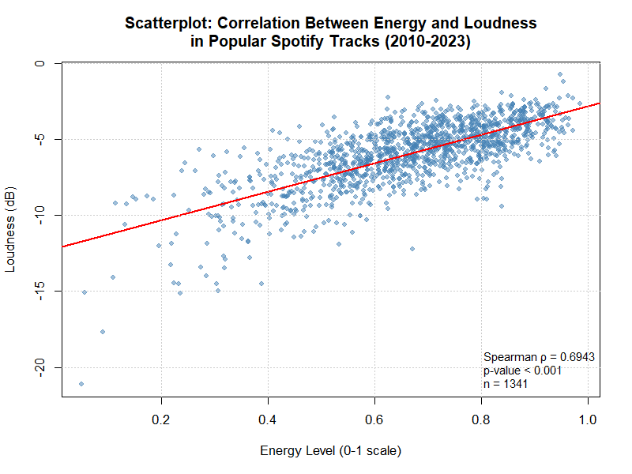
Figure 1

You would use a scatterplot and trendline for correlation research question since you're showing the relationship between two interval variables. Track is represented as single point Figure 1(a) where Loudness co-ordinates, the x-axis represents the energy of a track and y-axis stands for loudness. The red line is our line of best fit for direction and strength of the relationship.

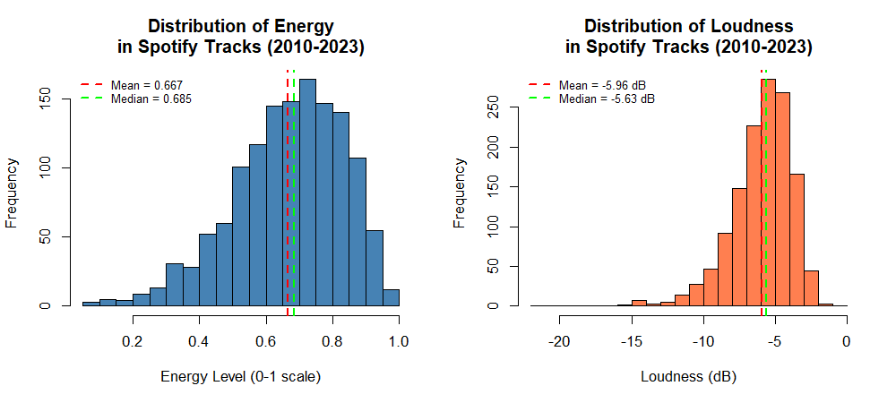
Figure 2

The histograms (Fig. 2) provide a review of the distribution characteristics of variables, to guide you to appropriate statistical tests. Both variables, however, are non-normal and Spearman's correlation is valid.

3.2 Additional information relating to understanding the data
The scatterplot reveals that tracks with more energy tend to pile up at higher loudness levels. The data points are erratic, especially at the high end, but the trend line steady . Most tracks are a bit louder (-8 to -3 dB) and mostly, the songs in the mid-energy tend to have higher loudness.

3.3 Useful information for the data understanding
- The energy distributions are shown to range between 0.052 and 0.985, with an average of 0.666.
- Loudness ranges from -21.1 to -0.74 dB (mean = -5.95 dB).
- Both are lopsided to the left. (unusual)
- Negative loudness numbers are also used in audio measurements, with 0 dB corresponding to the largest attainable amplitude.

